What is GDB?
The Digital Registries System (known as “GDB”) is a no-code platform allowing to create and administer professional databases easily, without programming.
Database schemas/structures are built through a simple, visual interface. The system provides advanced data management, log and connectivity options.
Each register created has a simple User Interface to capture, store, edit, search and present data, and an API connector with automatically-generated Open API services for machine-to-machine communication. It also maintains and reports logs of all operations taking place on schemas and data.
GDB is implemented to be highly integratable with eRegistrations systems.

Technical stack
The GDB is an inhouse application and consists of 3 main components that regular users and machine programs can use:
- Frontend is built with ReactJS and to be used by web browsers.
- Backend is built with the Django development framework (Python) that provides API for machine clients. The API uses Swagger documentation style to provide documentation for the whole API. Requests to API are secured by JWT token.
- Backend uses PostgreSQL database to store and read its data.

Besides the above mentioned components GDB uses Keycloak for Authentication, GTS for translations, ClamAV to scan uploaded files for viruses and Celery for tasks management.
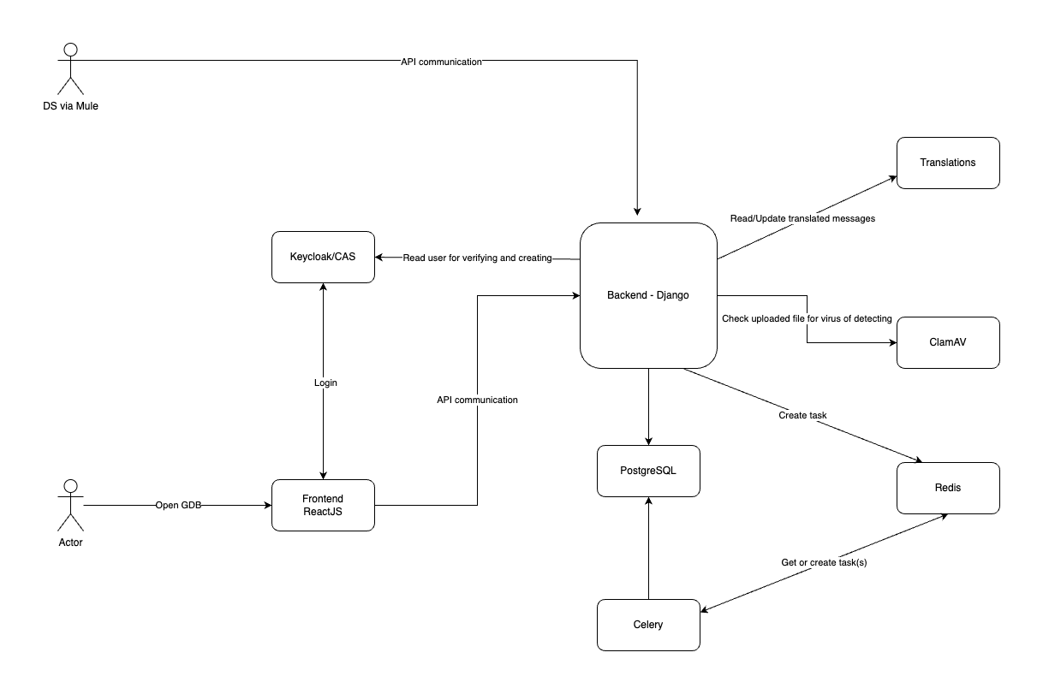

The system can be connected with ActiveMQ where it will send events every time an internal database has been published in order for newly generated APIs to be consumed.
For authentication, GDB accepts any number of OpenID connect servers.

